Student
Institution
Instructor
Date
PART 1:
1. What was the Scientific question(s) addressed
- What varieties of Microbial communities exists in soil and oceans.?
- How do the microbial community interact and how do they impact environment?
- How do the microbes affect complex processes such as specialization, pathogen defense and climate change?
2. What hypothesis(es) did the authors test?
H1: Microbes helps against plant defenses
H2: Skin microbiomes keeps frogs healthy
H3: Coral symbionts can help in protecting microbiome when there are thermal changes.
H4: Microbiomes can be used to differentiate ant species that are closely related.
3. What were the key results of the study?
- Coral host dinoflagellate symbiont which responds to thermal changes.
- By the sequencing of Colobopsis sp. and two Componotus spp., the microbes were stable in their development.
- There are 27 various types of bacteria that exhibits antimicrobial activity, thus the host species plays major role in ascertaining the composition of the skin microbiome.
4. Pick one figure from the study and interpret it
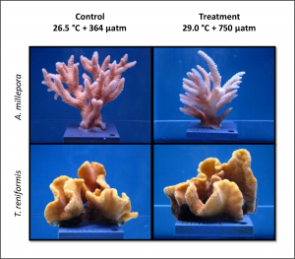
The figures above show two different corals, A. millepora and T. reniformis, under distinct two temperatures.
5. What is at least one important implication of the study?
The Antarctic penguins acts as canary in the coal mine and can alert people when there is increasing pollutants in water.
6. Relate this project to 2 things we studied so far this term.
The three ant-species study relates to the colony recognition that we learned.
It also relates with the use of microbiomes in protection against thermal changes that we learned.
PART 2
Answer the following:
1. What was the Scientific question(s) addressed
What are the major changes for the mitochondria after billion years of cohabitation.
2. What hypothesis(es) did the authors test?
H1: The mitochondria are not discrete jelly bean shaped as many books portray it to be.
3. What were the key results of the study?
After one year of cohabitation, the mitochondria turned into a domesticated organelle.
4. Pick one figure from the study and interpret it
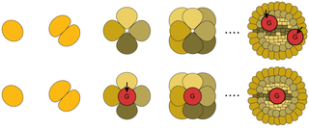
The figure shows zygote development to adulthood. The red section shows germline, which develops in different time periods in different organisms, as shown by the top and bottom rows. Research states that this depend on the mitochondria mutation rate, (Roland, 2017).

5. What is at least one important implication of the study?
If it wasn’t for the mitochondria, then we could have been developing our germlines after we reach sexual maturity.
6. Relate this project to 2 things we studied so far this term.
I. Mitochondria makes most of cell’s energy.
II. germline mutation causes congenital mitochondria disorder.

Work cited
http://blogs.plos.org/everyone/2018/06/08/wildlife_microbiomes/
http://journals.plos.org/plosbiology/article?id=10.1371/journal.pbio.2002338

